**PRINT PROFILE**

.data

prompt: .ascii "ahsan Sajjad \n"

class: .ascii "AGE : 19 "

.text

.global main

main:

li $v0,4

la $a0,prompt

#li $v0,4

#la $a0,class

syscall

li $v0,10

syscall

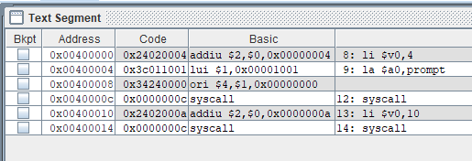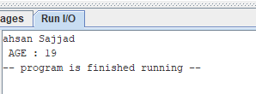

**ADD TWO NUMBERS**

.data

prompt: .ascii "THE SUM OF TWO NUMBER\n\n"

a: .word 10

b: .word 15

.text

.global main

lw $t0,a

lw $t1,b

add $t2,$t0,$t1

li $v0,4

la $a0,prompt

syscall

li $v0,1

move $a0,$t2

syscall

li $v0,10

syscall

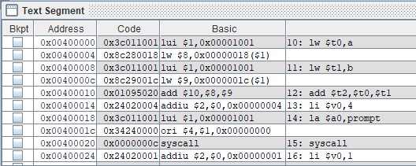

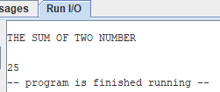

**Take two input and ADD TWO NUMBERS**

.data

prompt: .asciiz "ENTER FIRST number: "

prompt1: .asciiz "ENTER second number: "

prompt2: .asciiz "SUM of numbers : "

.text

.globl main

main:

li $v0,4

la $a0,prompt

syscall

li $v0,5

syscall

move $t0,$v0

li $v0,4

la $a0,prompt1

syscall

li $v0,5

syscall

move $t1,$v0

add $t2,$t0,$t1

li $v0,4

la $a0,prompt2

syscall

move $a0,$t2

li $v0,1

syscall

li $v0,10

syscall

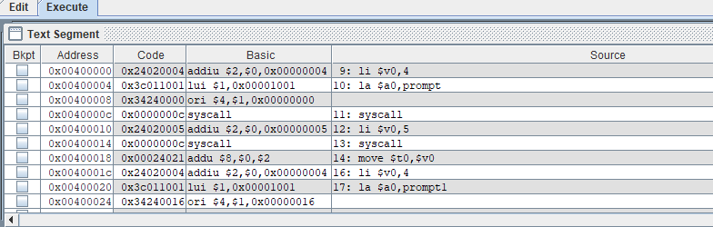

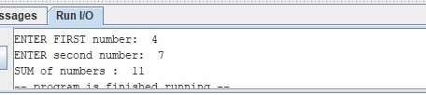

**Take two input and <MuL> TWO NUMBERS**

.data

prompt: .asciiz "ENTER FIRST number: "

prompt1: .asciiz "ENTER second number: "

prompt2: .asciiz "Multiply of numbers : "

.text

.globl main

main:

li $v0,4

la $a0,prompt

syscall

li $v0,5

syscall

move $t0,$v0

li $v0,4

la $a0,prompt1

syscall

li $v0,5

syscall

move $t1,$v0

mul $t2,$t0,$t1

li $v0,4

la $a0,prompt2

syscall

move $a0,$t2

li $v0,1

syscall

li $v0,10

syscall

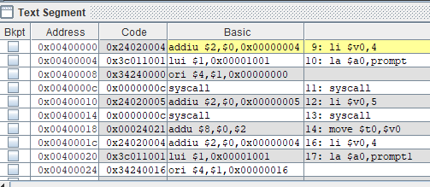

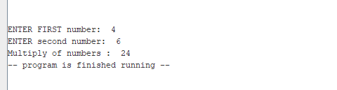

**Take two input and <DIVISION> TWO NUMBERS**

.data

prompt: .asciiz "ENTER FIRST number: "

prompt1: .asciiz "ENTER second number: "

prompt2: .asciiz "DIVISIOn of numbers : "

.text

.globl main

main:

li $v0,4

la $a0,prompt

syscall

li $v0,5

syscall

move $t0,$v0

li $v0,4

la $a0,prompt1

syscall

li $v0,5

syscall

move $t1,$v0

div $t2,$t0,$t1

li $v0,4

la $a0,prompt2

syscall

move $a0,$t2

li $v0,1

syscall

li $v0,10

syscall

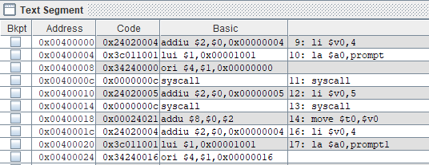

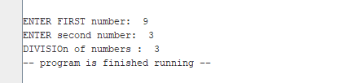

**PRINT STRING**

.data

p1: .asciiz "ENTER msg : "

p2: .asciiz "print msg :: "

p3: .space 26

.text

.globl main

main:

li $v0,4

la $a0,p1

syscall

li $v0,8

la $a0,p3

li $a1,26

syscall

move $t1,$a0

li $v0,4

la $a0,p2

syscall

li $v0,4

move $a0,$t1

syscall

li $v0,10

syscall

